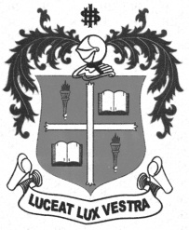
LOYOLA COLLEGE (AUTONOMOUS), CHENNAI – 600 034
M.A. DEGREE EXAMINATION - TAMIL LITERATURE
FIRST SEMESTER – NOVEMBER 2011

TL 1804 - TOURISM

Date : 11-11-2011 Dept. No. Max. : 100 Marks

Time : 1:00 - 4:00


 x=
- 
- 
- 
- 
-  (PASS PORT)(VISA)
- 



 x=
- 
- 
- 
- 
- 
- 




 x=
- 
- 
- 
- 
*******

